**Value Objects from Domain**

**Notes:-**

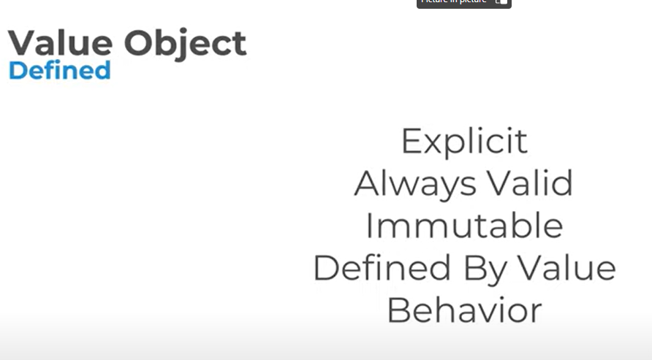

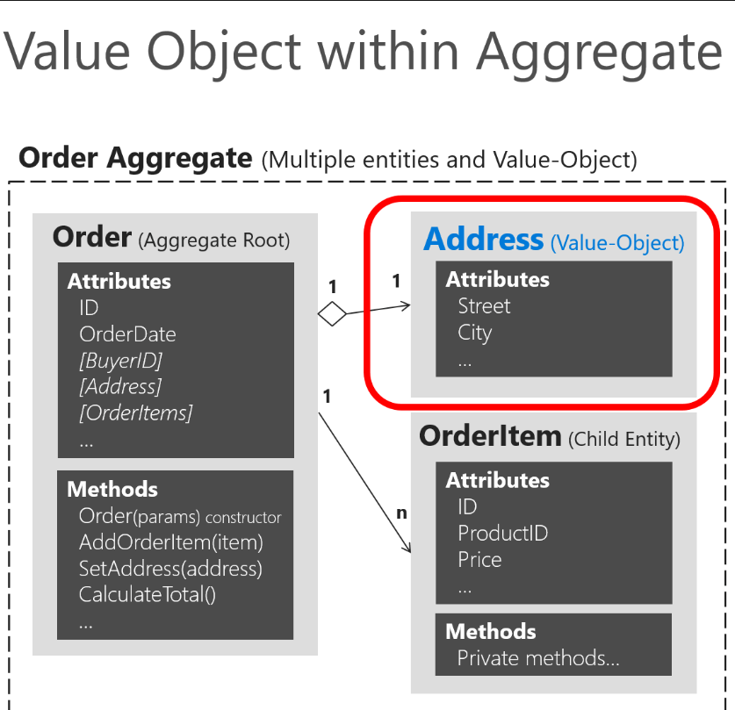

**1-The values of a value object must be immutable once the object is created.**

**2-Value objects allow you to perform certain tricks for performance, thanks to their immutable nature. This is especially true in systems where there may be thousands of value object instances, many of which have the same values. Their immutable nature allows them to be reused;**

**An owned entity type allows you to map types that do not have their own identity explicitly defined in the domain model and are used as properties, such as a value object, within any of your entities. An owned entity type shares the same CLR type with another entity type (that is, it's just a regular class). The entity containing the defining navigation is the owner entity. When querying the owner, the owned types are included by default.**

**public void Configure(EntityTypeBuilder<Order> orderConfiguration){**

**orderConfiguration.ToTable("orders", OrderingContext.DEFAULT_SCHEMA);**

**orderConfiguration.HasKey(o => o.Id);**

**orderConfiguration.Ignore(b => b.DomainEvents);**

**orderConfiguration.Property(o => o.Id).ForSqlServerUseSequenceHiLo("orderseq", OrderingContext.DEFAULT_SCHEMA);**

**//Address value object persisted as owned entity in EF Core 2.0**

**orderConfiguration.OwnsOne(p => p.Address).Property(p=>p.Street).HasColumnName("ShippingStreet");**

**orderConfiguration.Property<DateTime>("OrderDate").IsRequired();}**

**Owned entities capabilities**

**Notes:-**

**1-Owned types can reference other entities, either owned (nested owned types) or non-owned (regular reference navigation properties to other entities).**

**2-You can map the same CLR type as different owned types in the same owner entity through separate navigation properties.**

**3-Table splitting is set up by convention, but you can opt out by mapping the owned type to a different table using ToTable.**

**4-Eager loading is performed automatically on owned types, that is, there's no need to call .Include() on the query.**

**5-Can be configured with attribute [Owned], using EF Core 2.1 and later.**

**6-Can handle collections of owned types (using version 2.2 and later).**

**7-Value objects its used retrun value from other entity objects with other entities and its not trackable which means that its define once for all (once its create cannot be modifieid)**

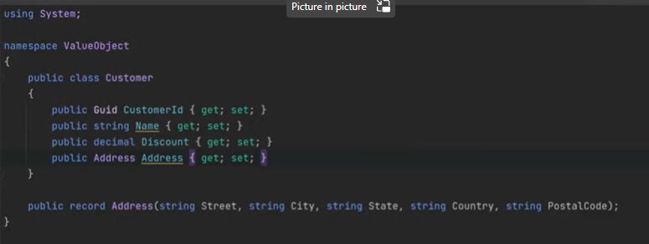

**We see that the address here is record type which is value type which means that all these prop are value type which means that is declared once for all**

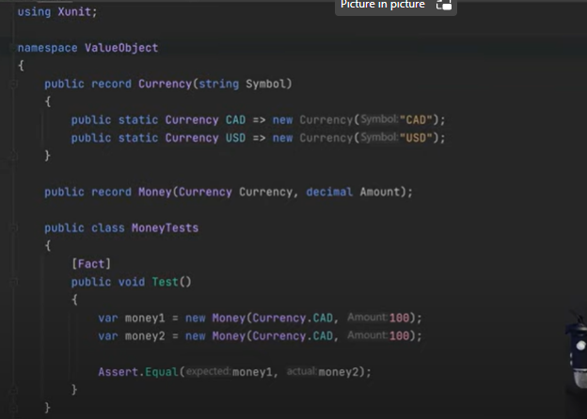

**Another concept is the money which is record which are using Currency as value type and define all the currencies we want as record**

